

**FUNDAMENTALS OF PROGRAMMING**

**Lab task # 7:**

**Name: Muhammad Yahya Chand**

**Roll #: 456727**

**Section: ME-15 B**

**Date: Nov 16,2023.**

**Submitted to: SIR. AFFAN**

**Task # 1:**

#include<iostream>

using namespace std;

int main(){

int a,b,c,d,e;

int f,g,h,i,j;

cout<<"insert ten integers: ";

cin>>a>>b>>c>>d>>e;

cin>>f>>g>>h>>i>>j;

cout<<"array is:";

int array[10]={a,b,c,d,e,f,g,h,i,j};

for(int i=0;i<10;i++){

cout<<array[i]<<" ";

}

return 0;

}

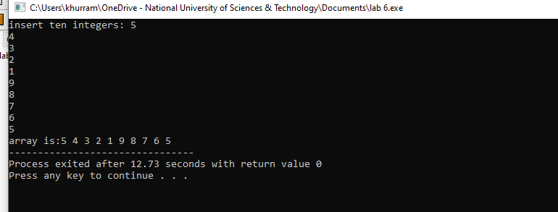

**Task # 2:**

#include<iostream>

using namespace std;

int main(){

int sum=0;

int product=1;

int v,w,x,y,z;

cout<<"enter five elements"<<endl;

cin>>v>>w>>x>>y>>z;

int array[5]={v,w,x,y,z};

for(int i=0;i<5;i++){

sum+=array[i];

product*=array[i];

}

cout<<"sum is"<<sum<<endl<<"product"<<product;

}

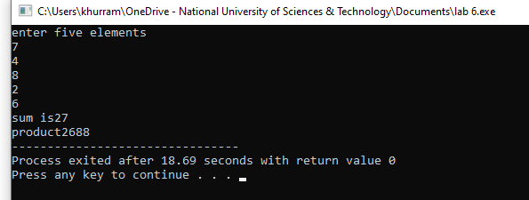

**Task #3:**

#include<iostream>

using namespace std;

int main(){

int size;

cout<<"enter the size of diamond: ";

cin>>size;

int half=size/2;

char diam[size];

for(int i=0;i<size;i++){

diam[i]=' ';

}

for(int i=0;i<=half;i++){

for(int j=0;j<size;j++){

diam[half-i]='*';

diam[half+i]='*';

cout<<diam[j];

}

cout<<endl;

}

for(int i=size;i>0;i--){

diam[i]='*';

}

for(int i=half;i>=0;i--){

for(int j=0;j<size;j++){

diam[half-i]=' ';

diam[half+i]=' ';

cout<<diam[j];

}

cout<<endl;

}

}

